# Corrected ADX Visualization with talib

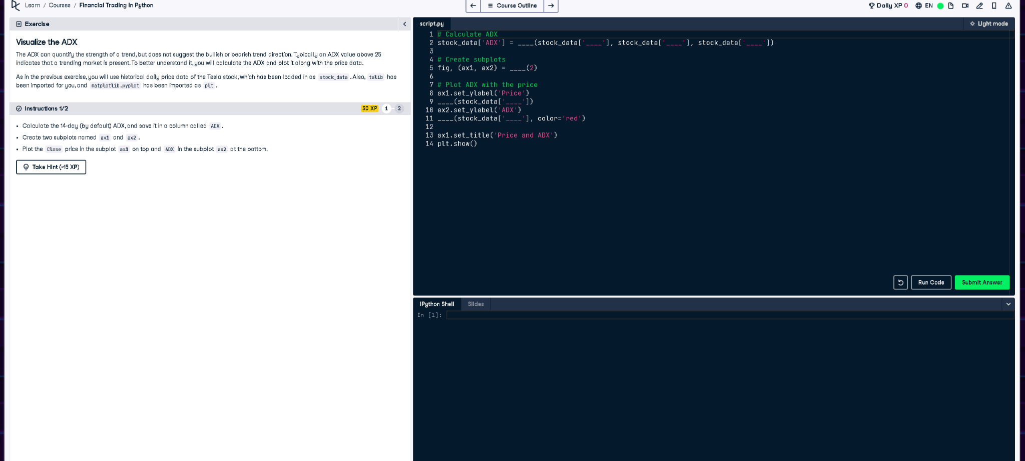

## Corrected Python Code

import talib  
  
# Calculate ADX using talib  
stock_data['ADX'] = talib.ADX(stock_data['High'], stock_data['Low'], stock_data['Close'])  
  
# Create subplots  
fig, (ax1, ax2) = plt.subplots(2)  
  
# Plot ADX with the price  
ax1.set_ylabel('Price')  
ax1.plot(stock_data['Close'])  
  
ax2.set_ylabel('ADX')  
ax2.plot(stock_data['ADX'], color='red')  
  
ax1.set_title('Price and ADX')  
plt.show()

## Updated Explanation (50 Words)

The original error occurred because the 'ta' library was not imported. Instead, we use 'talib', a technical analysis library. After importing it, we calculate the ADX using 'talib.ADX()'. The code then plots Tesla's price and ADX trend on two subplots for trend strength analysis.